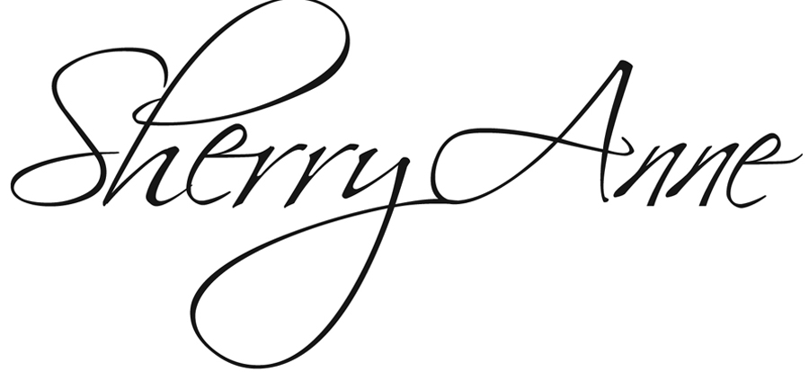
Press Release: DATE (USE for WORSHIP SERVICE VISIT)
For Immediate Release
Photo: download at http://sherryanne.com/photos.html
Note: Please use Sherry Anne in its entirety as a professional name reference. Thank you.

Award-Winning Hearing-Impaired Singer-Songwriter Sherry Anne to Perform at (INSERT YOUR VENUE NAME OR LOCATION)

Award-winning hearing-impaired singer-songwriter Sherry Anne will sing as part of the INSERT TIME service at INSERT CHURCH NAME, INSERT ADDRESS, TOWN on INSERT DAY, DATE. Visitors are welcome. Make plans now to hear and see this inspirational artist share a life-changing message in word and song.

Although born with a bilateral hearing and speech impairment, Sherry Anne sings with an elegant voice and inspires audiences with the story of her journey from being seen as a problem child to a now-sought-after singer and motivational speaker.

Sherry Anne has appeared on stage with Bill Gaither and The Gaither Vocal Band, the Booth Brothers, the Collingsworth Family, The Hoppers, and Triumphant Quartet. Her song “You Came,” co-written with Tony Griffith, was a Singing News Songwriting Contest Grand Prize winner and has charted in both The Singing News and Billboard Magazine. Learn more at sherryanne.com.

MEDIA CONTACTS:
. INSERT CHURCH CONTACT PERSON AND NUMBER
. Sherry Anne Ministries Publicist Kara Lynn Dunn, landline 315-465-7578, karalynn@gisco.net

