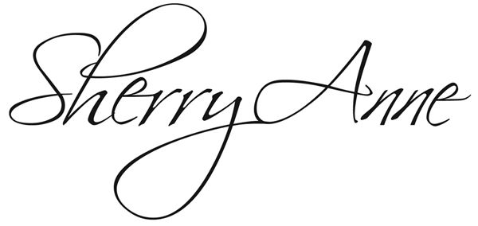
Checklist to Help You Promote Your Sherry Anne Concert Event
This checklist is offered to help you promote your event to the fullest so that the blessing that comes through hearing the gospel in music and song is available to all those in your community and in neighboring communities. Find press release and poster templates, bio, photos, video and audio clips online at www.sherryanne.com.

SPECIAL NOTE: When sharing news of your Sherry Anne event, please use her professional name of Sherry Anne in its entirety.

___ Posters: http://sherryanne.com/press.html
Fill in the event poster template at http://sherryanne.com/press.html with event date,
address and details. Copy and post at your church, in church bulletin; distribute in community to other churches, grocery/post office bulletin boards…

___ Press Release: http://sherryanne.com/press.html
Fill in the press release template at http://sherryanne.com/press.html with your event details. 3-6 weeks ahead of date, email, deliver or mail release to area newspapers, regional magazines, radio/tv stations within 2-hour drive. Include Christian radio headquartered elsewhere but broadcasting to local area.

___ Online EVENT Calendars
Enter your event details on the online community/events calendars of your church, local newspapers, radio/tv stations, Chamber of Commerce.

___ Social Media/AUDIO-VIDEO LINKS: http://sherryanne.com/press.html
Post your event info/invitation and Sherry Anne audio/video clips to the church Facebook and Twitter accounts, add YouTube link to her promotional video.

___ Talk to People, Personally Invite Others.

___ Ticket Sales
If you are selling tickets to the event, consider asking a local business to sponsor tickets for a youth group or senior citizens to attend the concert.

___ Interview Shows
Contact any radio/tv station with a local news/events talk show to ask to share the date, time, place, free or any cost/ ticket info, and contact person for your event

___ Advertising
If your event has a budget for advertising, contact local media to learn the costs, deadlines and any formatting requirements for placing a concert ad.

Need Assistance? For help with your promotion efforts, contact Sherry Anne Ministries Publicist Kara Lynn Dunn at 315-465-7578 (landline), kara@sherryanne.com: please put Sherry Anne Concert Event in the Subject Line.

